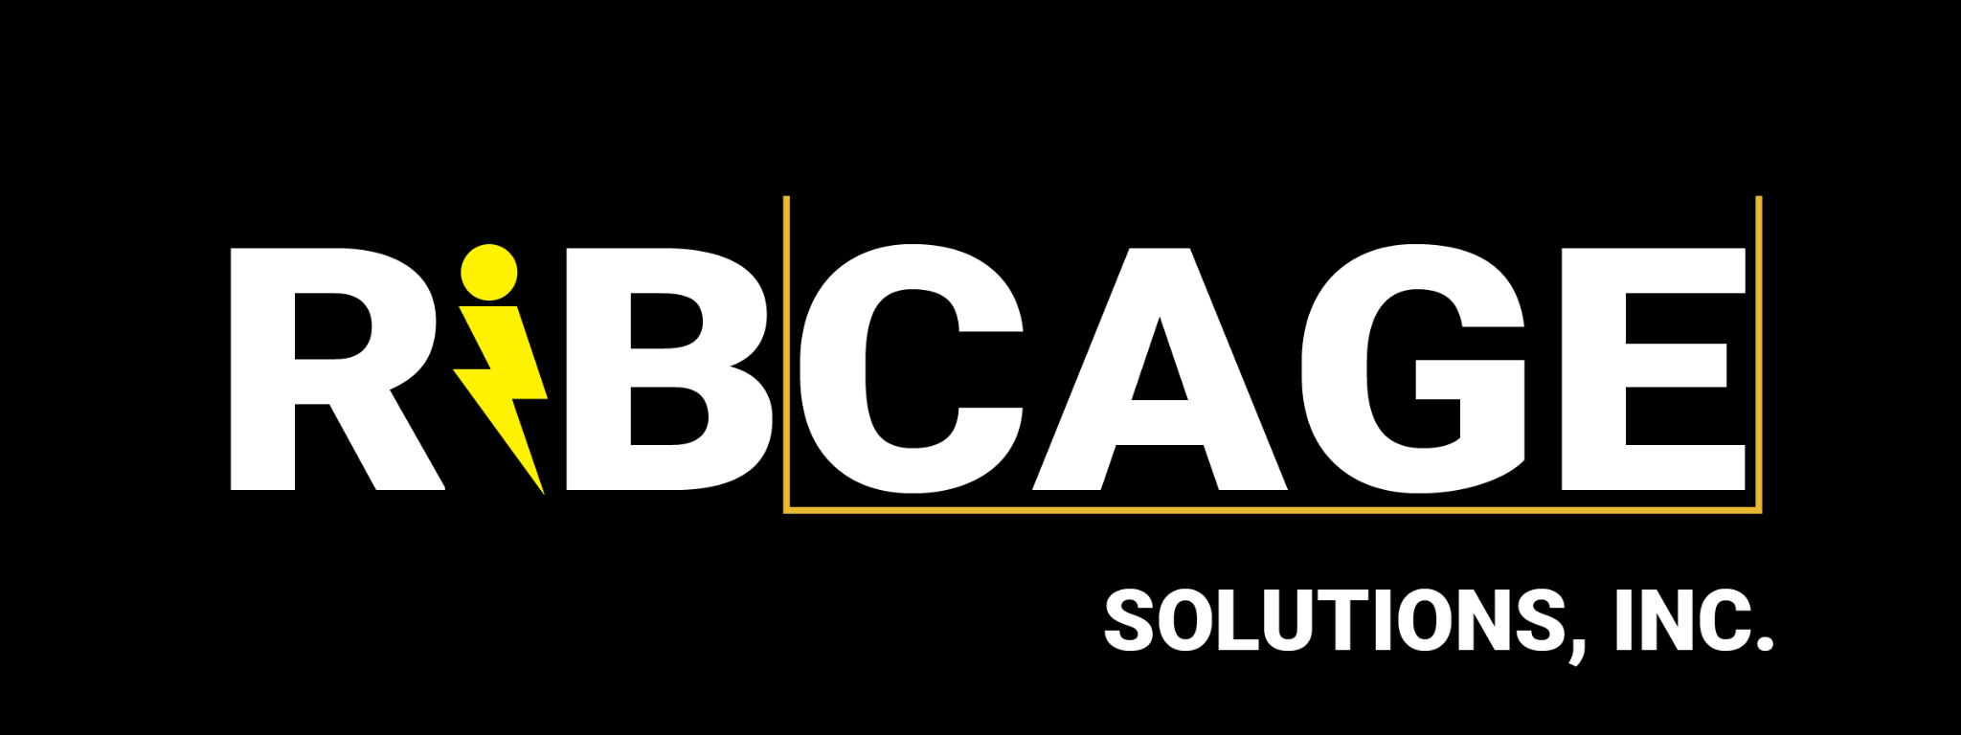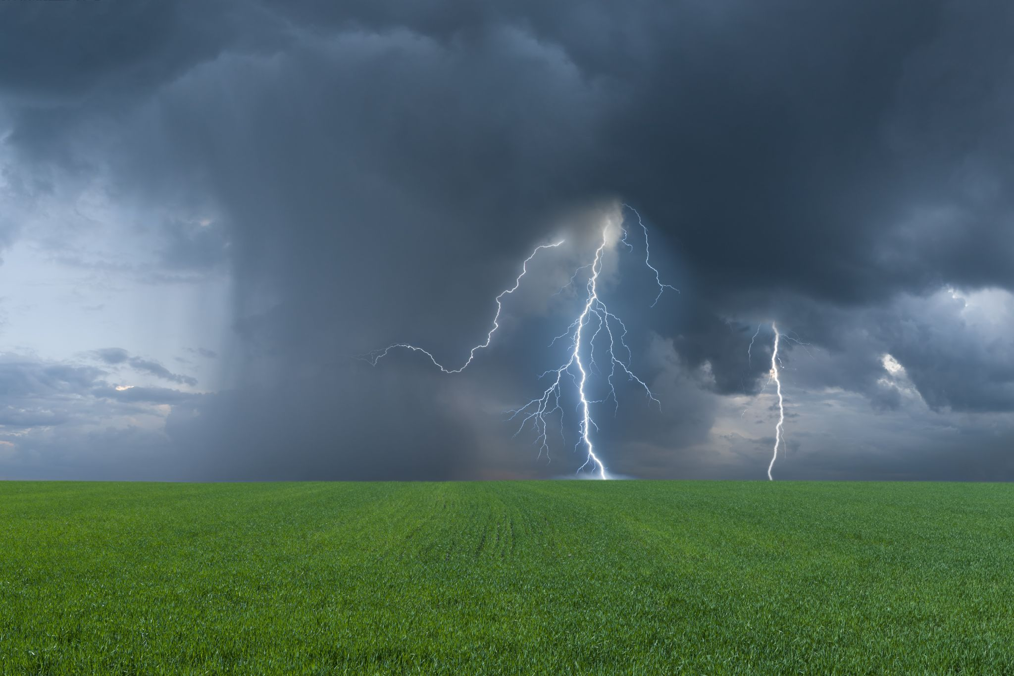

MODULAR LIGHTNING PROTECTION KIT

FOR MOTION PICTURE PRODUCTION

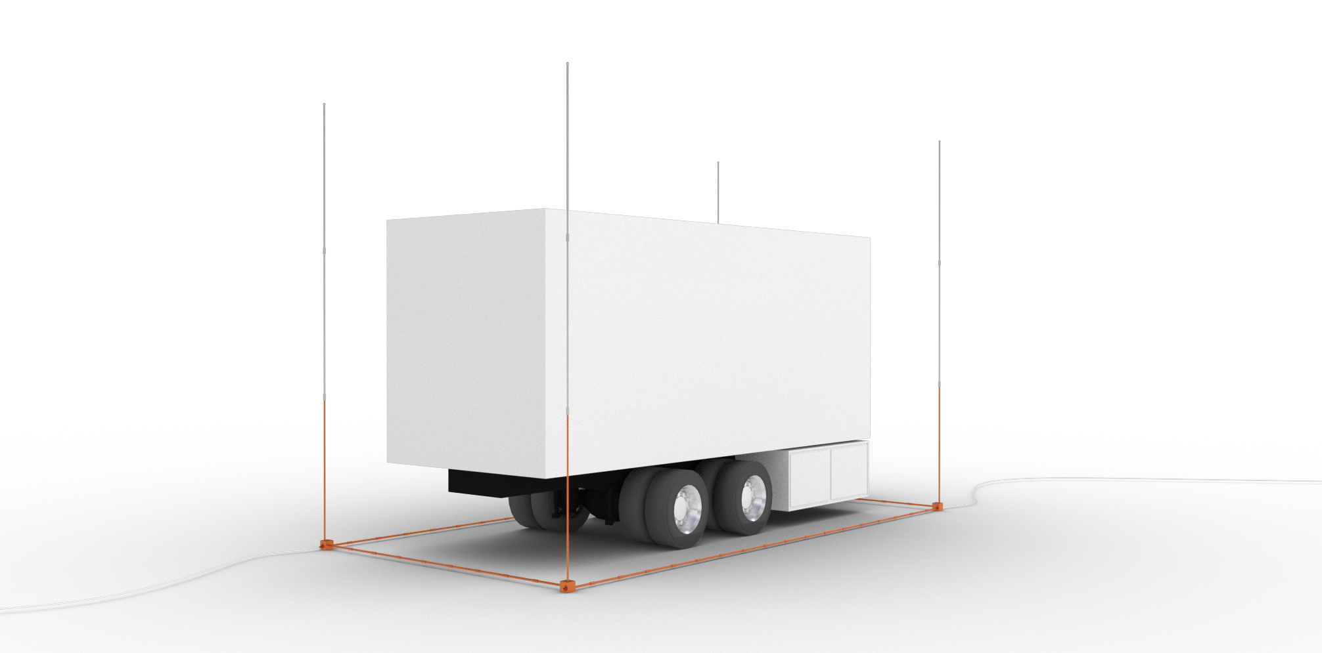*Rendering of an assembled ArcAngel kit for a rented 220 kW towable generator.*

# **PURPOSE**

As a standard routine, motion picture productions have been shutting down indoor work due to 30/30 rules because their generators cannot be modified for lightning safety without breaching rental contracts. Not only is this practice generally unsafe, but it also causes incredible financial damage over time from the cumulative loss of work due to 30/30 rules. This damage is not currently tracked or calculated by studios.

**Our patent-pending modular lightning protection ArcAngel kit enables productions to** **protect mission critical equipment from lightning strikes** before lightning appears so work can continue inside during 30/30 rules.

# **INDUSTRY STANDARDS**

Designed and engineered with the help of LPI-IP Master Installers, the RIBCAGE KIT creates a zone of protection around an object **according to the NEC** (NFPA #780)**, LPI** (LPI-175)**, OSHA and NOAA** (29 CFR 1926.35, generator safety, inclement weather safety, lightning safety, and general workplace safety requirements) compliance standards, respectively and with **UL-96A approved components.**

# 

**Our kits are designed specifically for incorporation into Motion Picture Production Emergency Action Plans** and contingencies when working in high ground flash density or lightning prone areas such as states like Georgia, New Mexico, Florida, Texas, and Virginia.

**EXAMPLE 30/30 RULE EAP CONTINGENCY FOR INDOOR WORK:**

“If a 30/30 Rule is called but work might be able to continue indoors, then check if your equipment’s generator possesses a lightning protection system. If yes, continue working. If not, shut down.”

# 

# **RISK MITIGATION WITH ARCANGEL KIT**

Productions have many risks associated with direct and indirect lightning strikes and there are various mitigation strategies, **but only a ARCANGEL KIT from RIBCAGE SOLUTIONS can MITIGATE THE RISK OF LOSS OF WORK due to 30/30 RULE CALL SHUTDOWNS** by effectively protecting generators without requiring warranty-voiding modification or expert electrical and mechanical engineering.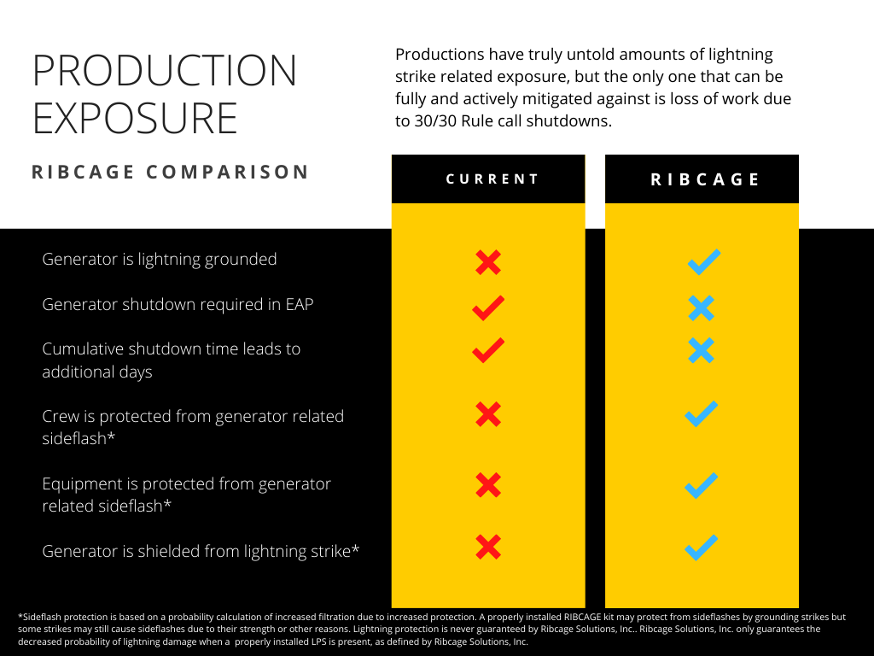

# 

# **EASY ASSEMBLY & DISASSEMBLY**

Our modular design has **ONLY** **TEN COMPONENTS** and allows for quick and easy assembly with **NO WELDING** and **NO TOOLS**.

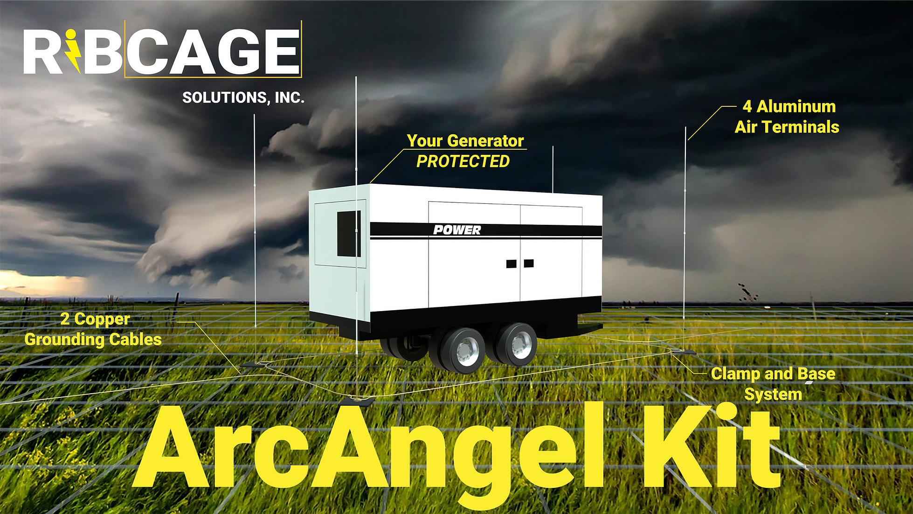

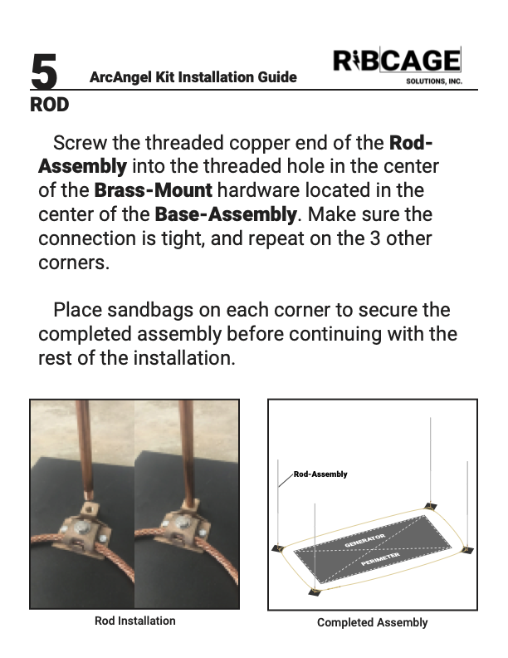

**With our easy-to-follow assembly instructions,** **properly installed ArcAngel kits are guaranteed to pass inspection!**

# **SAFETY INSPECTIONS**

After the production crew assembles a ArcAngel kit, a UL and LPI certified virtual inspection is scheduled with Intercept Lightning Protection. Any installation mistakes found in the inspection must be corrected.

After Intercept’s professional inspectors find that an installation accords with lighting protection standards, that particular ArcAngel installation **receives a CERTIFICATE OF INSPECTION** from Intercept Lightning Protection**.**

Since our engineers designed our products alongside inspectors, the required assessments can always be completed in a timely manner.

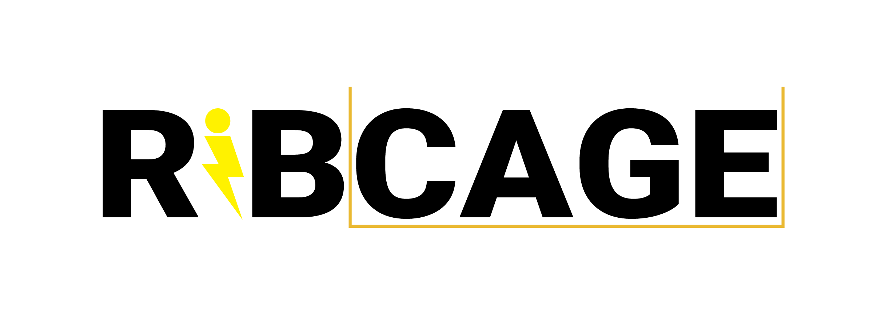

Contact us

[info@ribcagesolutions.com](mailto:info@ribcagesolutions.com)

**470-600-CAGE (2243)**

We look forward to hearing from you!

RIBCAGE SOLUTIONS INC. in no way provides or lays claim to any provision of any mode of insurance against lightning related events and assumes no liability for related damages, regardless of “protection” status, to items or people inside a RIBCAGE. We only claim that RIBCAGEs adequately ground generators for lightning strikes and that a lightning strike *should* be grounded by our system, although it is still possible for a lightning strike to overpower our lightning protection system or for other environmental factors to interfere with the effectiveness of lightning protection systems. RIBCAGEs are sold solely as a piece of equipment to satisfy conditions for generator related workplace safety when in a shelter during a lightning storm. Use at your own risk.